

**This is Me**

**Information about me for an Education Health and Care (EHC) needs assessment**

**‘This is Me’ is a form for you to fill in which helps other people understand what you think and feel about school or college. You can ask someone you trust to help you think about what’s important and answer the questions.**

You can write your answers on this form, or you can add the information online straight into the [EHC hub](https://ehchub-devon.openobjects.com/).

**You can access this using a computer, tablet or smart phone.**

To do that you will need to have been invited to use the EHC Hub and then registered to use it. If this hasn’t happened, contact the SEN 0-25 team to ask about it. If you’re using the Hub, you can also upload your views as a video, pictures or photos as well.

The boxes below will get bigger as you type if you’re adding lots of information. That’s OK! If you need help to fill out the form or need some ideas, there’s some tips on pages three and four.

|  |  |  |  |
| --- | --- | --- | --- |
| **Your name** |  | **Your date of birth** |  |
| **The name of anyone who helped you fill this is, and who they are (such as mum)** | |  | |
| **Date you filled this in** |  | | |

|  |  |
| --- | --- |
|  | **Things that are important to me** |
|  | |

|  |  |
| --- | --- |
|  | **Things that are working well at home and at school** |
|  | |

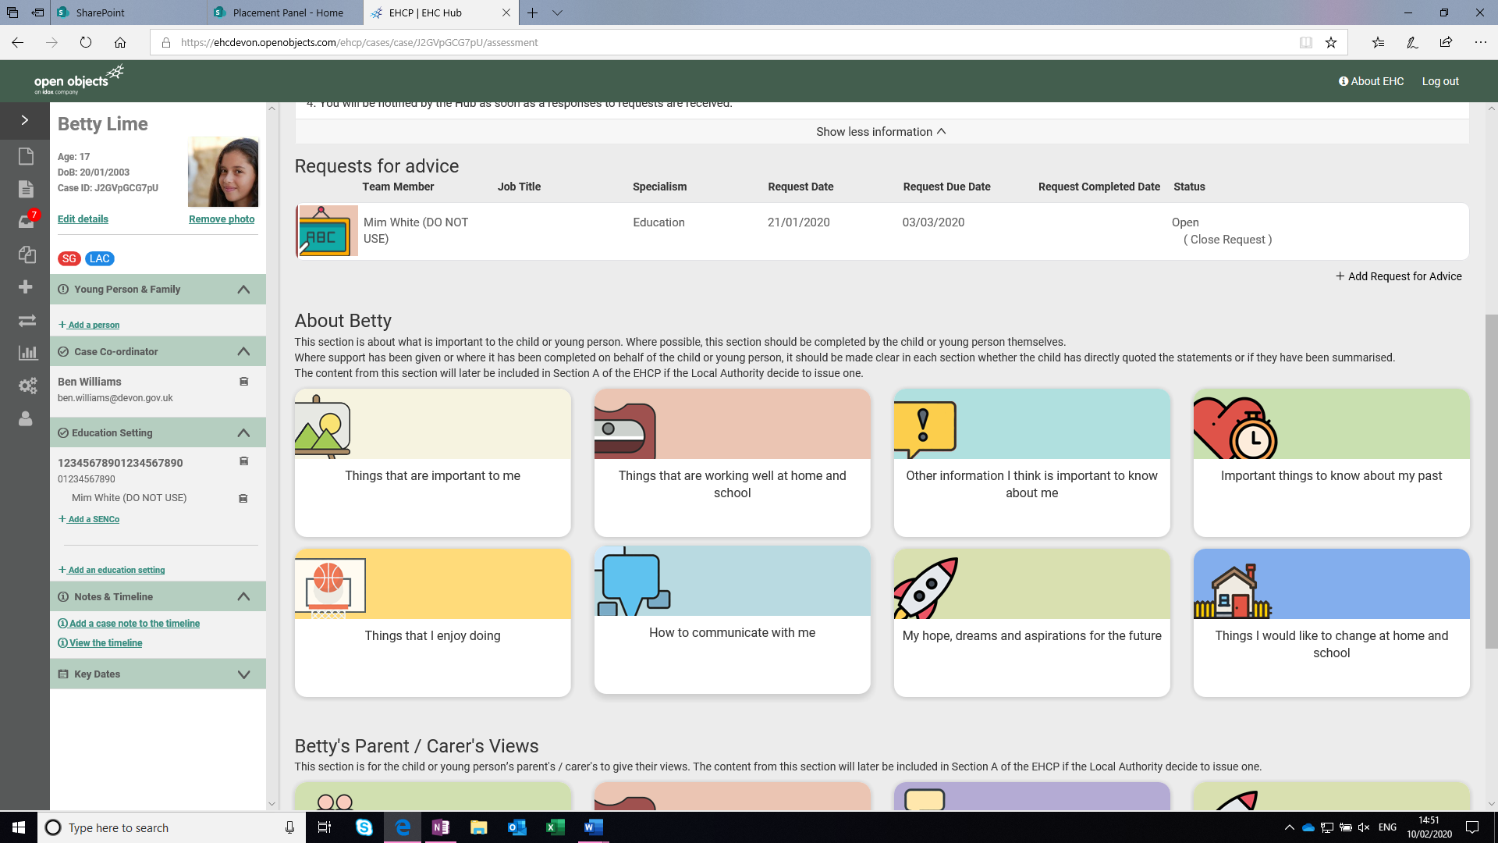

|  |  |
| --- | --- |
|  | **Other information I think is important to know about me** |
|  | |

|  |  |
| --- | --- |
|  | **Important things to know about my past** |
|  | |

|  |  |
| --- | --- |
|  | **Things that I enjoy** |
|  | |

|  |  |
| --- | --- |
|  | **How to communicate with me** |
|  | |

|  |  |
| --- | --- |
|  | **My hopes, dreams and aspirations for the future** |
|  | |

|  |  |
| --- | --- |
|  | **Things I would like to change at home and school or college** |
|  | |

|  |
| --- |
| **How to fill in ‘This is Me’** |
| **Why do I need to fill this in?**  Being involved in the decisions made about your future is important. Filling in the form or giving your views can help to tell others what you’re good at and what you need help with. You can write down your thoughts about school and college and what you would like to do in the future.  The information you give is sent to the SEN 0-25 team at Devon County Council. They decide who needs an Education, Health and Care plan. To help them decide if you need one, they will look at what you say. They will also ask your parents or carers about you, as well as the other people that support you.  **You can use other ways of recording your views, such as making a film, doing a drawing or writing things down on plain paper instead of using This is Me.**  **What do I need to say?**  The SEN 0-25 team need to know:   * what you’re good at and the things that are important to you to make your life enjoyable * the things you find difficult and things that are important for you to be able to learn * your goals and what would you like to do in the future   **I’m not sure what to write**  There are some ideas on the next page to help you think about what to write.  **I need help filling this in**  You can ask an adult you know to help you (don’t forget to put their name at the top of the form) or you can contact DiAS at www.devonias.org.uk or call on 01392 383080 for help. |

|  |
| --- |
| **Top tips for filling in the form** |
| * Remember that there are no right or wrong answers. Everyone is different - the SEN 0-25 team want to know about you and what you think. * Your views and ideas might be different from your school’s or your parents’. That’s OK. * Chances are, you won’t have met the people at the SEN 0-25 team who will decide whether you need an EHC plan. You can add videos, pictures or drawings to make it clear who you are and what your goals are. * It’s helpful if you can say **why** you enjoy certain things or find certain things difficult. For example, you might say ‘I enjoy playing computer games’ and that’sgreat. But if you can say what makes it enjoyablefor you too, that’s even more helpful. So maybe it’s because you like spending time with your friends online, or maybe it’s because you like playing strategy games that make you think. The more you can say about it, the better! |

**Here are some ideas to help you share your views in ‘This is Me’**

|  |  |
| --- | --- |
| **Things that are important**  **Things that are working well**  **Things that I enjoy** | **Things I would like to change at home and school or college** |
| Think about things like   * what motivates you and what are you proud of in yourself * what other people like and admire about you * the things that make you happy * your skills and the subjects you find interesting * family life, friends and social life * hobbies, leisure time and interests * anything or anyone that helps you at school, or anything you couldn't do without * your health, sports and exercise * getting around, being independent and getting where you want to go | Think about what you may need help with, such as:   * remembering, planning or organising things * understanding schoolwork, taking exams or getting help with your learning * getting around school or out and about * relationships and friendships * understanding rules, instructions or other people * your health, taking care of yourself or staying safe * family and social life * hobbies and interests |

|  |
| --- |
| **My hopes, dreams and aspirations for the future** |
| These are some ideas...   * If you want to go to college, what type of college would you like to go to? * What subjects would you like to study? * Would you like to go to work or volunteer? What sort of jobs or volunteering are you interested in? * What do you need to learn before you can go to college or get a job? * Where would you like to live? Who would you like to live with? |

|  |
| --- |
| **I’ve filled it in. Now what?**  Save a copy before you email or post it. Then send a copy to:   * SEN 0-25 Team, Room L102, County Hall Topsham Road, Exeter EX2 4QD or * specialeducation0-25-mailbox@devon.gov.uk |

Created by Devon Information Advice and Support DIAS to support Devon County Councils EHC needs assessment process

**Tel:01392 383080 email: devonias@devon.gov.uk www.devonias.org.uk**

**Published March 2023**



